## Problem Statement

Ask a home buyer to describe their dream house, and they probably won't begin with the height of the basement ceiling or the proximity to an east-west railroad. But this playground competition's dataset proves that much more influences price negotiations than the number of bedrooms or a white-picket fence.

We need to predict the sale price of the houses based on given 79 variables.

## Data

## EDA

### Checking the output variables to predict

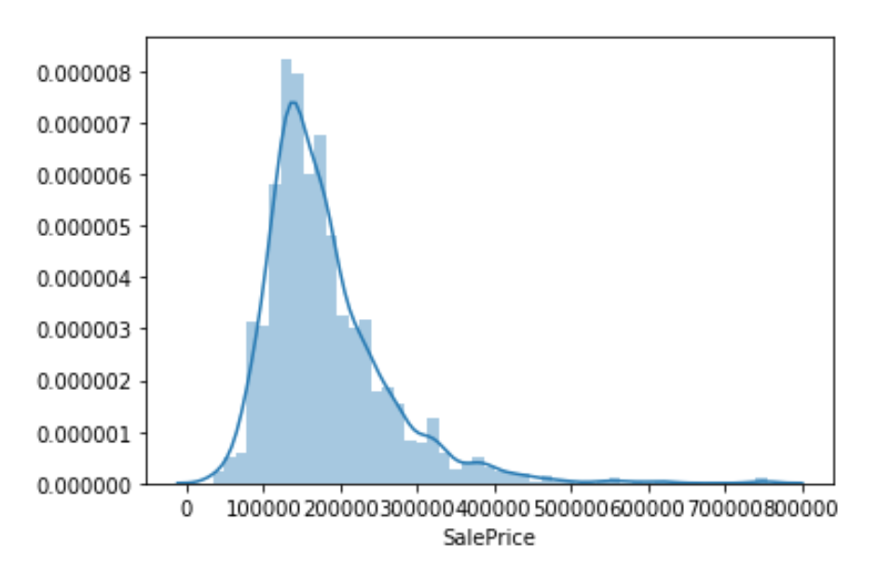

### Variable types

### Relation of output variable with others

### Correlation between all variables using Heatmap

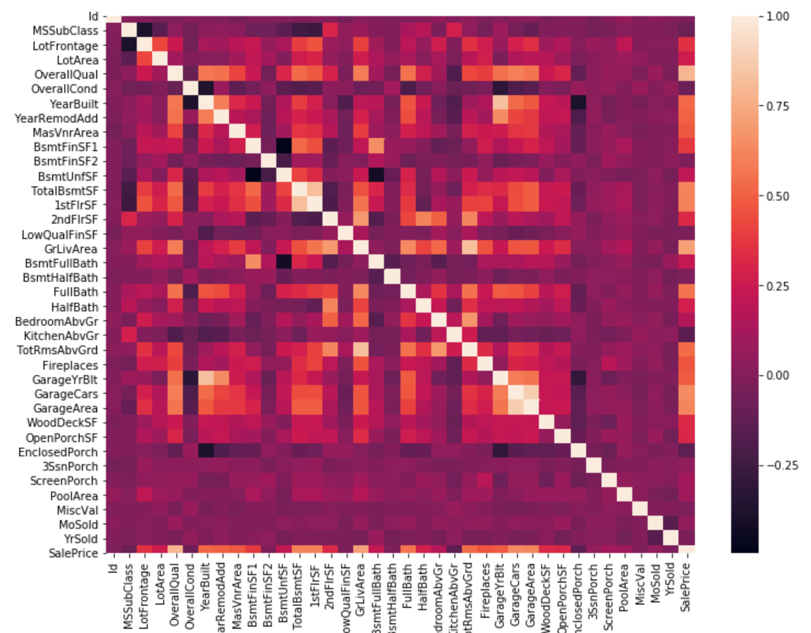

### Pairplot for further digging relation between variables

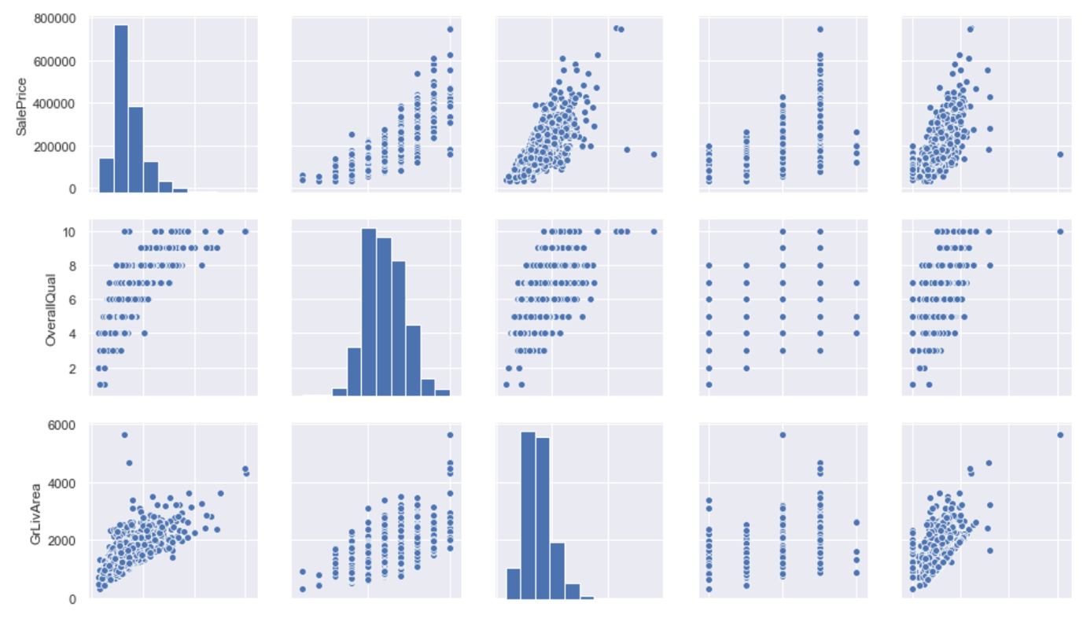

### Handling Missing Data

### Detecting Outliers

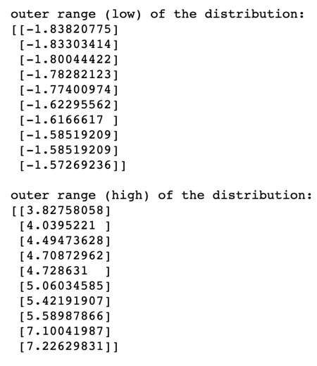

### Making variable distribution normal

### Homoscedasticity

### Prediction

